NOTICE OF REQUEST FOR INFORMATION SYNOPSIS | NATO UNCLASSIFIED  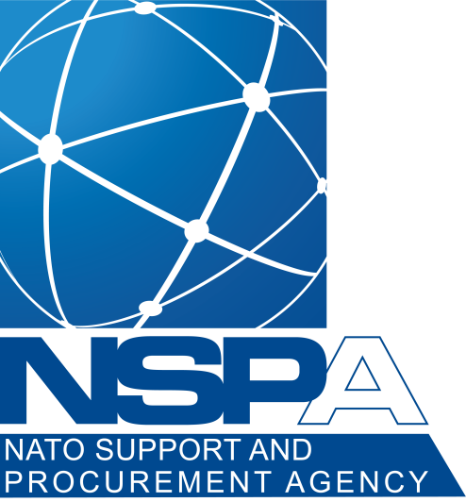
FOR AN INITIAL

ALLIANCE FUTURE SURVEILLANCE AND CONTROL (AFSC) CAPABILITY

Version 1, dated 12/12/2022 | Directorate of Lifecycle Management  Acquisition Planning and Development Office (APDO)  NATO UNCLASSIFIED

Contents
1 Purpose of the Request for Information (RFI) 3
2 Overview of the Initial AFSC Capability 3
3 Initial AFSC Capability Requirements 3
4 Responses 3

Purpose of the Request for Information (RFI)

The NATO Support and Procurement Agency (NSPA) in support of the Alliance Future Surveillance and Control (AFSC) project is seeking information on how interested contractors could develop an Initial AFSC Capability that fulfils the requirements of Full Operational Capability (FOC) the 2035 timeframe.

THIS IS A REQUEST FOR INFORMATION SYNOPSIS ONLY. This RFI Synopsis is issued solely for information and planning purposes – it does not constitute an Invitation for Bid (IFB) or a promise to issue an IFB in the future. This request for information Synopsis does not commit NATO to contract for any supply or service whatsoever.

Overview of the Initial AFSC Capability

The current NATO Airborne Early Warning and Control (NAEW&C) Capability is provided by 14 NATO E-3A AWACS aircraft which will reach the end of their operational life and will be phased out around 2035. A new generation of surveillance and control capabilities will be defined under the Alliance Future Surveillance and Control (AFSC) Project. The AFSC capability will establish a system of systems architecture that will allow the integration of multiple capabilities and platforms to enable multi-domain operations.

Concerning the transition from the current capabilities to the AFSC, NATO is pro-actively exploring options to mitigate potential risks, in particular related to the day zero Airborne Early Warning and Control (AEW&C) and Air Battle Management capability currently provided by the NATO AWACS.

On behalf of NATO and interested NATO Nations, NSPA has been tasked to explore options by considering the acquisition of an Initial AFSC Capability. This Initial AFSC Capability is intended to be integrated in the future as one contributing element of the overall AFSC capability.

NATO and the interested NATO Nations are considering combining efforts to acquire this Initial AFSC Capability for use by NATO.

Initial AFSC Capability Requirements

NSPA is seeking, in coordination with NATO IS Defence Investment Division, Industry responses to a Request for Information (RFI) including Rough Order of Magnitude (ROM) Price & Availability, to provide NATO and the interested NATO Nations with relevant information on a number of key aspects including existing market capabilities, potential applicable contractual frameworks, and potential benefits of a cooperative approach.

Responses
4.1 If your company has the prime contract capability to manufacture and deliver an existing MoTs solution for the potential Initial AFSC Capability by the end of this decade to meet an Initial Operational Capability (IOC) by 2031, you may request a copy of the RFI from the sole NSPA Point of Contact (POC) Mr Ravindranath Dourgah at ravindranath.dourgah@nspa.nato.int, no later than 18 December 2022.

THIS IS A REQUEST FOR INFORMATION (RFI) SYNOPSIS ONLY to identify sources that can provide an Initial AFSC Capability. The information provided in the RFI Synopsis is subject to change and is not binding on NATO. NSPA has not made a commitment to procure any of the items discussed, and release of this RFI Synopsis should not be construed as such a commitment or as authorization to incur costs for which reimbursement would be required or sought. All submissions become NATO property and will not be returned.

